# Non-cooperative games

* A game **strategy** in most context means the decisions players can make in a game
* A **Zero-sum game** has one player’s loss being the other player’s gain
* A **non-co-op game** has players playing against each other for their own interest

## Payoff and payoff matrix

* We can define a **payoff** for each player’s individual strategies
* We can express all the strategies and their payoffs in a game with a **payoff matrix**

|  |  |  |
| --- | --- | --- |
| A\B | Strat C | Strat D |
| Strat C |  |  |
| Strat D |  |  |

= Payoff for A, payoff for B when both players choose strategy C

## Dominant Strategy Equilibrium

* At the D-Strategy Equilibrium, **all players have a dominant strategy** and won’t change their strategy anymore
  + The best decision for a player is the dominant strategy
  + As everyone will choose said strategy, we can predict the game’s outcome

## Nash Equilibrium

* If **no single player changes their strategy**, given that **other players don’t change their strategies**, their decisions is at a Nash Equilibrium
* Because at the D-Strategy equilibrium, all players won’t change their strategy, a **D-Strategy Equilibrium must be a Nash Equilibrium**
* To find the Nash Equilibrium, put yourself in a player’s shoes and see if they would change their strategy assuming the other players won’t.

### Mixed strategies

* The probabilities for each player to make each possible strategy when the game is repeated many times is the mixed strategy
  + It is called a **pure strategy** if the **probability of a mixed strategy = 1**

### Mixed Nash Equilibrium

* If **no single player changes their mixed strategy**, given that **other players don’t change their mixed strategies**, their decisions is at a Mixed Nash Equilibrium
* **Every finite n-player non-cooperative game has a mixed Nash equilibrium.**

### Finding the Mixed Nash Equilibrium

Suppose (p, q) is a mixed strategy for the players to choose strategies (C, D):

* is the **expected payoff** for player A when their mixed strategy is (p, q)
* It is calculated by multiplying the probability for each strategy to their respective payoffs for player A

Let be a mixed Nash equilibrium, . For all :

## Auctions

|  |  |  |  |  |
| --- | --- | --- | --- | --- |
| Auction System | Bidding process | Winner determination | Payoff if win | Payoff if lose |
| First-price sealed bid | Bids submitted without know other’s bidding amount | Highest bidder wins |  | 0 |
| Second-price sealed bid | Highest bidder wins, **pays only the second-highest bid** |  |
| English | Increasingly high bids are placed if desired | Last remaining bidder wins |  |
| Dutch | Auctioneer announces lower and lower price tags | First bidder to accept price wins |  |

# Cooperative games

* A **co-op game** has players preferring to work together

Co-op games can be modelled in **coalitional form** as followed:

* Assume a game with n players, number from 1 to n
* Let game be where .
* Any **subset** S of N is called a **coalition** (e.g. {1,2} {1} {1,2,3})
  + A heart shaped diagram with numbers

    Description automatically generatedN is the **grand coalition**
  + Ø is the **empty coalition**
* is called the coalition function
  + The number is called the **value of the coalition S**
* Define all when modelling a game as coalitional form ()

We can use a **balloon figure** to represent the coalitions of a 3-player game

* If , then players are **symmetric players**
* If , then player is a **null player**

## Shapley value

The conditions or whatever for Shapley value doesn’t really matter, here are 2 ways to calculate the value

### Splitting the game

Split the original game into all different games that have different players. Yeah it’s kinda hard to put it into words, just if it’s a 3-player game then split it into 7 games [{1}, {2}, {3}, {1,2}, {2,3}, {1,3}, {1,2,3}], and have the payoffs only exist for such pair of players.

Then just divide the payoff evenly between the players in the coalition. Yeah it’s confusing just too at the example.

### Using Shapley’s formula

Shapley value

* represents a permutation of grand coalition
* represents set of players before excluding itself
* represents set of players before including itself
  + Example:
* Use a table to calculate the coalition values in different coalitions:

|  |  |  |  |
| --- | --- | --- | --- |
|  |  | | |
|  | A | B | C |
| ABC |  | … | … |
| ACB |  | … | … |
| BAC |  |  | … |
| BCA |  |  | … |
| CAB |  | … |  |
| CBA |  | … |  |
|  |  |  |  |

*Example:*

* Sum of all

# Infectious disease modelling

## SIR model (numbers)

The total population N is divided into 3 disjoint groups:

1. **Susceptible class**

People who are susceptible to the disease

1. **Infective class**

People who are infected with the disease

1. **Removed class**

People who recovered, are immune or have died

is the number of people in this class at time t

* There are people moving from to per unit of time
* There are people moving from to per unit of time

Hence, we can interpret the meaning for :

* is the infection parameter, which depends on the mode of transmission (infectious)
* is the average duration of infectious period

Notice for :

* – infection grows
* – infection diminishes

### The reproduction number

is the avg. no. of secondary infections produced by one infective per unit time

* is the no. of new cases arising from one infective per unit time ()

## sir model (proportions)

Assuming no births or immigrationN constant:

* is the contact rate (A contact is assumed to have a 100% transmission rate)
* SIR data can be recovered by multiplying with N

is the average number of contacts with the infected that an individual experiences per unit time

is the number of susceptible that fall ill from contact with the infected per unit

This gives

### The contact number

is the average number of contacts during the entire infectious period

**When**

## Vaccinations

* Herd immunity: Ensure that no epidemic can take place even with few infections
* If the fraction of the population that is susceptible then an epidemic cannot occur
* Thus, to ensure herd immunity, the vaccinated population percentage must be
* Considering the efficacy of the vaccination, the corrected

# Adjusted winner procedure

The Adjusted winner procedure can be used to determine who gets what

## Procedure

1. Each item is awarded to the person who values it most:
2. The tied items are given to whomever has fewer points at the time
3. The first item to the transferred is the item with the lowest value ratio from player splitting
4. The item is split between the two players to make the points even

### Example

1. **Each item is awarded to the person who values it most:**

|  |  |  |  |  |
| --- | --- | --- | --- | --- |
|  | Point distribution | | |  |
|  | A [60 pts] | Item | B [75 pts] |  |
|  | **35** | House | 15 |  |
|  | 20 | Investments | **25** |  |
|  | 10 | Piano | **25** |  |
|  | 5 | TV | **15** |  |
|  | **25** | Dog | 10 |  |
|  | 5 | Car | **10** |  |

1. **As the points are not equal, an item is split to whomever has fewer points at the time**

As in points, B is giving an item to A

1. **The first item to the split is the item with the lowest value ratio from player splitting**

As B is giving an item to A, we’re calculating the value ratio

Investments is to be split

1. **The item is split between the two players to make the points even**

Let be the fraction of investments given to A:

|  |  |  |  |  |
| --- | --- | --- | --- | --- |
|  | A [66.67 pts] | Item | B [66.67 pts] |  |
|  | **35** | House | 15 |  |
|  | **20** | Investments | **25** |  |
|  | 10 | Piano | **25** |  |
|  | 5 | TV | **15** |  |
|  | **25** | Dog | 10 |  |
|  | 5 | Car | **10** |  |

# Error-Control Codes

We need redundancy in transmitted data to ensure the correct data is received after the data is affected by noise during transmission

## Terminology

**Data**  Original message

**Codeword** Message sent(encoded data)

**Code rate** Ratio of data length over codeword length (improvement if ratio 🡪 1)

**Correction power** n amount of digit errors (transposition or alteration) that can be corrected

## Check digits

Check digits is a redundant digit for validation, allowing us to detect or even correct errors.

### Population systems

**HKID**

**10d ISBN**

**13d ISBN**

**Credit card**

## Binary codes – ASCII

|  |  |
| --- | --- |
| Single-parity-check codes A parity check bit appended to each data unit 🡪 even number of 1’s in valid codeword  Correction power: 1-errors  Code rate: 7/8 (high) | Binary repetition code Each bit is repeated 3 times, the valid codeword has 3 equal bits  Correction power: 1-errors  Code rate: 1/3 (low) |

## Hamming (7,4) code

The best coding method for 1-errors correction, with an acceptable code rate of 4/7 (>1/2)

Correction power: 1-errors

For: the highlight bits are the parity check bits, the value is deduced by *(XOR)*:

■■▣■▣▣▣

■■▣■▣▣▣

■■▣■▣▣▣

* There are only 16 valid codewords representing all possible 4-bit messages in all 7-bit words
* Distance between codewords suggest the number of bits that the codewords differ
* The minimum distance between valid codewords for this coding is **3**

## Detection / correction power of a code

For a code with minimum distance :

* **Detection**  errors
* **Correction**  errors
  + The valid corrected codeword has the closest distance to the original codeword

# Secret codes

## Cryptosystems

A cryptosystem is secure if the following components are kept secret:

1. Encryption / decryption algorithms
2. Encryption / decryption keys

* Key space: The collection of all possible keys in the system

## Modular Arithmetic

If

For , note the following properties:

To compute the modulus of a number D:

To find : express as

## Ciphers

### Symmetric ciphers

Symmetric ciphers: The decryption process is the reverse of encryption process for the system

1. **Shift cipher**

Shift characters in a message

Key space = 26

1. **Substitution cipher**

Replaces characters in a message

Key space = 26!

### Asymmetric ciphers

Consists of a public key and a private key. Senders encrypt the message with the public key, and the message can only be decrypted with the private key

### RSA algorithm

* Co-prime: numbers share no common factors

To determine the keys, two prime numbers are picked. These prime numbers should be **long**.

Encryption key (n, e)

Decryption key (n, d)

Ciphertext

Plaintext

To find :

# Daily life uncertainties

Relative frequency – the probability of an outcome when repeated infinitely many times

Sum of probabilities must equal to 1

|  |  |  |  |
| --- | --- | --- | --- |
|  |  | A & B | Intersect |
|  |  | A or B | Union |
|  |  | not A | Complement |

Probability for something to occur twice =

## Conditional probabilities

For probability of B given that A occurred:

## Event types

Independent:

Mutually exclusive:

## Tree diagrams

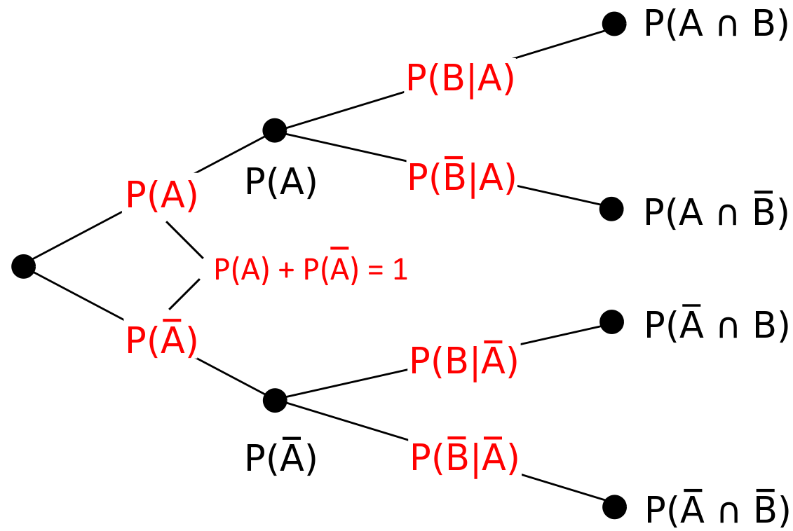

# Mathematics of Internet Search

## PageRank Algorithm

The score is the quantitative rating of a web page’s importance.

A backlink is the number of links to the page

A page has a higher score if it’s:

1. Pointed to by more pages
2. The pages pointing to it are important

**We denote the following for pages :**

Total number of pages

Number of outward links

Weight

Score , where is the iteration count

Initial score

Link matrix

* There’s a diagonal of 0 since there’s no link from a page to itself
* Number of elements in row (page) number of back-links
* Sum of row
* Number of elements in column (page) number of out-links
* Sum of column is 1

### Limiting Scores Theorem

Note that

Suppose the web is interconnected in a way that one can go from any page to another, we say that the link matrix is irreducible, and A is a stochastic matrix (+ve entries, col sum = 1)

According to the theorem:

* Either
* Or the average of

If the link matrix is not irreducible but is still a stochastic matrix:

We use

# Machine learning

## Information gain

For attribute ,

is the list of tuples of subsets after choosing as the branding attribute.

Probability of positive classes in attri

Expected information

Information needed

Information gain

## Support Vector Machine

SVM is one of the most popular learning algorithms, which is used for classification. It finds a vector with the largest margin from data points, separating two classes of data, +ve and -ve

**Steps to find the support vector (Decision boundary):**

1. Make sure the points are linearly separable
2. Find the margin hyperplane H+ between two boundary, positive points
3. Find the margin hyperplane H- by moving the line towards negative points until touching one
4. The decision boundary is between H+ and H-

### Separating points linearly

* If we can separate 2 classes of points with a single straight line, they are linearly separable
* Else, we can introduce a mapping where is some function of . There must be a mapping that makes the classes linearly separable.

## Clustering

### k-means algorithms

1. Select initial k points as centroids at random
2. For other points, calculate their distances to each centroid, and assign them to the closest cluster
3. Update each centroid as the mean of the points assigned to it
4. Repeat previous 2 steps until no change

The algorithm has these few disadvantages:

* Cannot discover clusters that are not ellipsoids
* Will group outliers

**Distance formulas:**

* Distances:
* Euclidean distance:
* Manhattan distance:

I LOVE YOU <3